UP-132E PE Upright 52” Steinway & Sons
Purchased from Irene Besse in 2013, used only less than 1 year
Excellent condition/ same as new

Sale will be Included,
Upgraded with adjustable chair $303.45
Damp chaser $446.25
Piano cover $519.99

Boston 132E Upright Piano at home  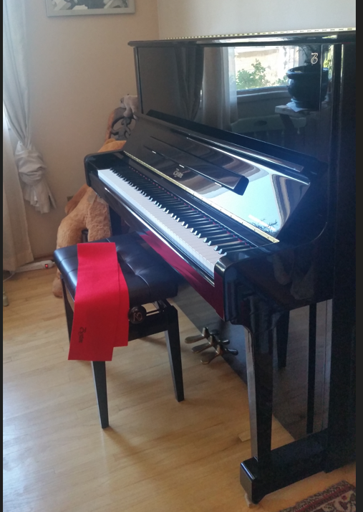 | Boston 132E Upright Piano at home  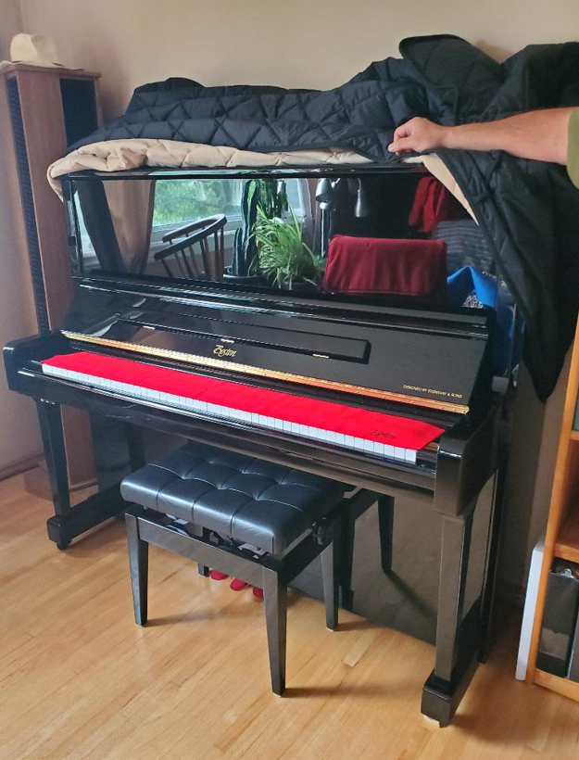
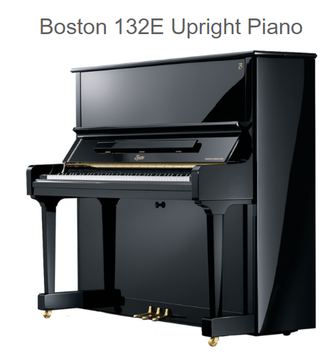 | 